Computing the 3d Position of an Object from two Pan-Tilt cameras

The need for obtaining one single PAN angle from both cameras is due to two facts:

1) Historically, the lab worked with a head that had a neck and needed a singular pan and tilt value (LVerge, RVerge, Pan, and Tilt). In the current configuration of the head, there are two independent pan and tilt values. Hence, there needed to be a conversion to obtain a single pan angle, “α”.

2) To compute the position of an object of interest marked by the angles of the cameras, a single pan and tilt angle are necessary to formulate distance equations for X, Y, and Z.

X = D
Y = y2
Z = Height

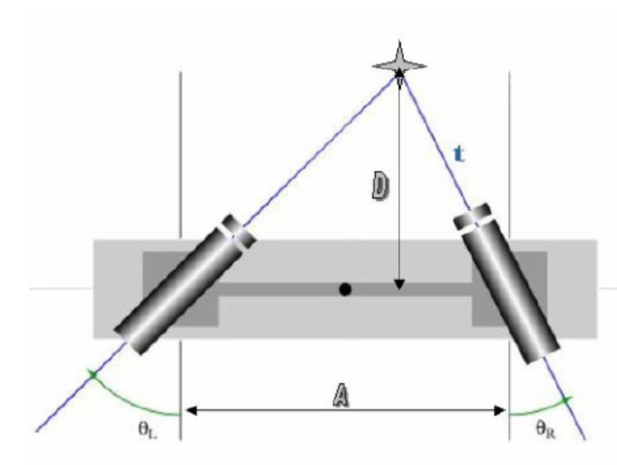
First, set the interior triangle angles as:

θ_{L}= 90 - B_{L}
θ_{R} = 90 – B_{R}

θ, we found t to be:

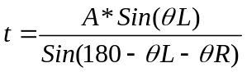

Simplifying,

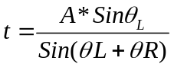

Hence, we find D = X to be:

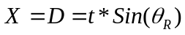

Substituting for t, and expanding the expression for D:

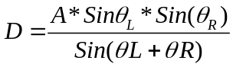

After having computed the distance, we now proceed to try to compute the singular value for the pan angle. From our diagram below and comparing it to the diagram above, we see that the pan value is the same as alpha, α:

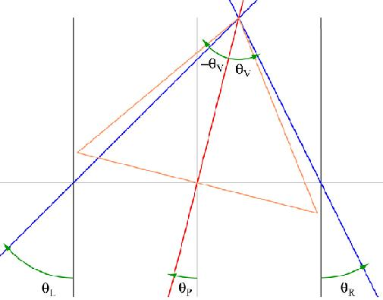 | 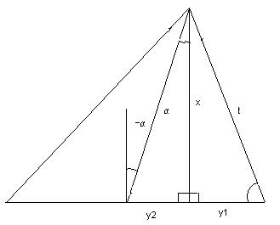

Now we want to find Y, which is equivalent to:
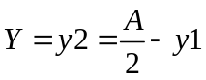

Since Y is a function of y1, we have to find the latter. Looking at the diagram, we can find the following relationship for y1:

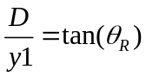

Substituting for D and solving for y1:

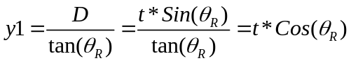

Hence, Y = y2 is:

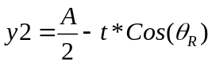

Next, we wish to find Z, which is the vertical height formed by both cameras. To find Z, we must first find the length of the hypotenuse formed by the singular pan angle.

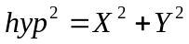

Z can then be computed by using the angle formed by the average tilt of both cameras:

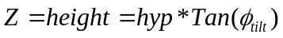

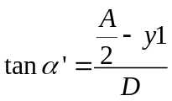
Substitue for y1 and D,
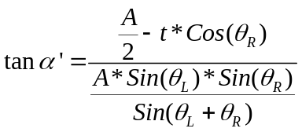
Expand t,
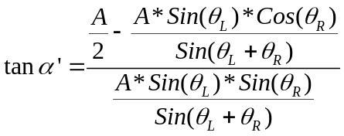

Multiply the top and bottom by 2 and by the denominator Sin(θ_{L}+θ_{R}),
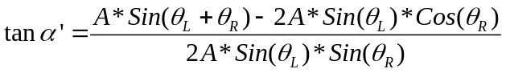

Divide by A, and expand the Sin(θ_{L}+θ_{R}) term,
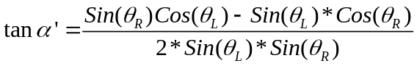
Simplify,
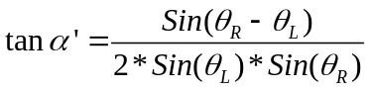

So, we just find the arctan of alpha to get our desired angle (look at fig. 1):

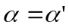

This is the actual mathematical model that was used in the PTCatch.cpp source code.

This angle as well as an average of both tilts can be obtained from the vector signal for the PTCatch component by invoking operation 2. The angles outputted would be:
left pan, left tilt, right pan, right tilt, overall pan angle, average tilt angle.
There are other models that can be adopted to find this angle. One of them was presented by Prof. Peters. It will be presented here below to show that the final result is identical.

The model is based on the following diagram:

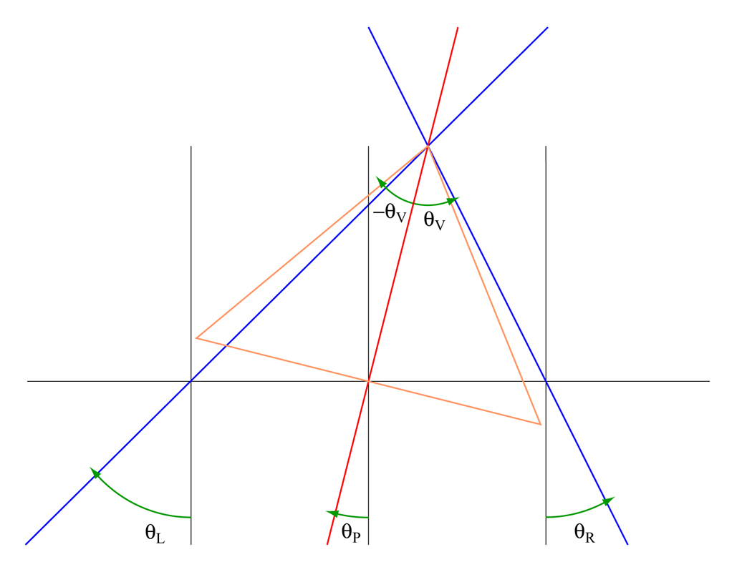
Where clockwise rotations represent negative angles and counterclockwise rotations represent positive angles.
Based on this model, you can get θR and θL:

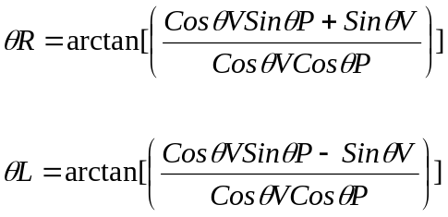

And the Pan angle is:

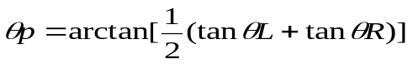

We can solve for the following identity:

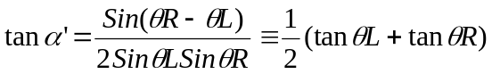

Solving for the LHS:

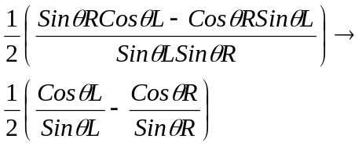

Here we have to realize that the angles that were selected for both models are different. So:

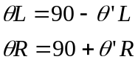

Hence, by doing the appropriate substitution we get:

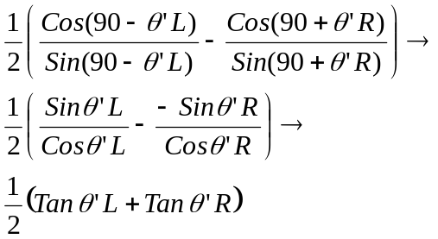

Hence both sides of the equation are equal.

